***Category***

*Random Forest HOG*

***Random Forest***

**Author:Michał Pomarański, Po-Tsung Chiu, Chun-Jen Peng**

Version:

Status:Draft

Publication:2014-11-07T22:43:31Z

Copyright:

**Modeliosoft**

MINES ParisTech

Table of Contents

Please, select this field and press F9 to create/update the table of contents

# Package Index

|  |  |
| --- | --- |
| RandomForestHOG |  |
| HOG | Package responsible for creating HOG representations of images |
| DecisionTree | Package contains the classes used in decision tree |
| RandomForest | Package contains class RandomForest and class RandomForestLearner. |

# Package "RandomForestHOG"

from Package gforge

Figure 1 Random Forest HOG Class diagram

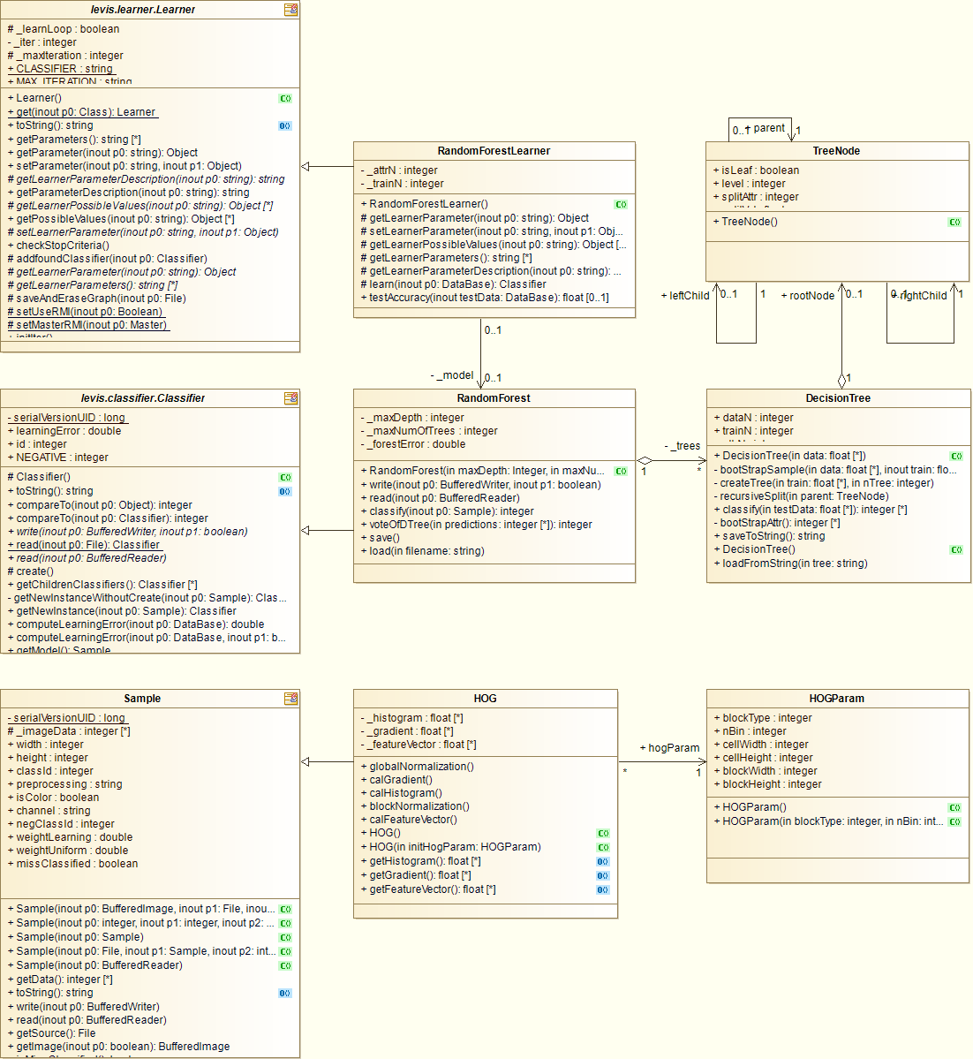

| Name | Summary |
| --- | --- |
| HOG | Package responsible for creating HOG representations of images |
| DecisionTree | Package contains the classes used in decision tree |
| RandomForest | Package contains class RandomForest and class RandomForestLearner. |

Table 1 Owned Packages of Package "RandomForestHOG"

# Package "HOG"

from Package gforge.RandomForestHOG

| Name | Summary |
| --- | --- |
| HOGParam | Class contains a set of parameters for HOG |
| HOG | Class responsible for creating HOG representations of images |

Table 2 Owned Classes of Package "HOG"

## Class "HOGParam"

from Package gforge.RandomForestHOG.HOG

This class bundles the essential parameters to perform HOG.

Figure 2 HOGParam (architecture_autodiagram)

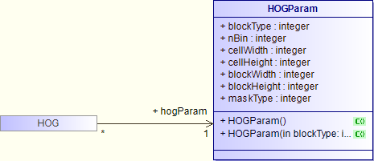

| Name | Description |
| --- | --- |
| HOGParam () | initialize instance of HOGParam with default setting |
| HOGParam (In blockType integer,In nBin integer,In cellWidth integer,In cellHeight integer,In blockWidth integer,In blockHeight integer,In maskType integer) | initialize instance of HOGParam with manual setting |

Table 3 Operations of Class "HOGParam"

| Name | Description |
| --- | --- |
| blockType : [1..1] integer | the type of block (either rectangular or radial) |
| nBin : [1..1] integer | number of bins for creating histogram |
| cellWidth : [1..1] integer | width of each cell |
| cellHeight : [1..1] integer | height of each cell |
| blockWidth : [1..1] integer | width of each block |
| blockHeight : [1..1] integer | height of each block |
| maskType : [1..1] integer | type of the mask to calculate gradients |

Table 4 Attributes of Class "HOGParam"

## Class "HOG"

from Package gforge.RandomForestHOG.HOG

Inherits from: Sample

This class implements the operations involved in HOG, and create arrays of pixel's data of each stage.

Figure 3 HOG (architecture_autodiagram)

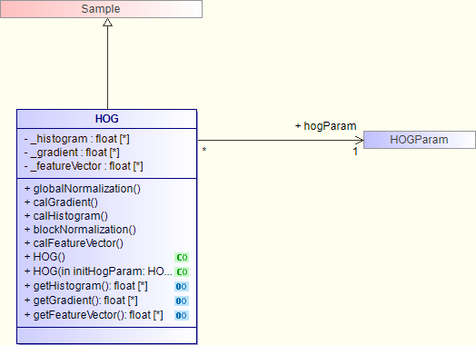

Interaction "HOG computation"

Figure 4 HOG computation

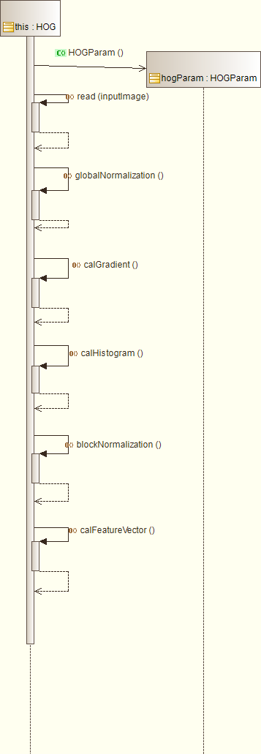

| Name | Description |
| --- | --- |
| globalNormalization () | pre-process the image with global normalization [optional] |
| calGradient () | calculate the gradients of each pixel with certain mask |
| calHistogram () | calculate the histograms of each pixel |
| blockNormalization () | apply block-wise normalization on the image |
| calFeatureVector () | calculate feature vectors of each pixel |
| HOG () | initialize HOG instance with default parameter setting |
| HOG (In initHogParam HOGParam) | initialize HOG instance with certain parameter setting |
| float getHistogram () | return the value of histogram array |
| float getGradient () | return the value of gradient array |
| float getFeatureVector () | return the value of featureVector array |

Table 5 Operations of Class "HOG"

| Name | Description |
| --- | --- |
| _histogram : [0..*] float | array of histograms of each pixel after calculation |
| _gradient : [0..*] float | array of gradients of each pixel after calculation |
| _featureVector : [0..*] float | array of feature vectors of each pixel after calculation |

Table 6 Attributes of Class "HOG"

| Name | Description |
| --- | --- |
| ->hogParam : [1..1] HOGParam | set of HOG parameters used in HOG computation |

Table 7 Associations of Class "HOG"

# Package "DecisionTree"

from Package gforge.RandomForestHOG

| Name | Summary |
| --- | --- |
| DecisionTree | Class contains interface for using Decision Trees. |
| TreeNode | Class defines the nodes of a tree data structure |

Table 8 Owned Classes of Package "DecisionTree"

## Class "DecisionTree"

from Package gforge.RandomForestHOG.DecisionTree

This class implements operations about decision tree in random forest learning.

Figure 5 DecisionTree (architecture_autodiagram)

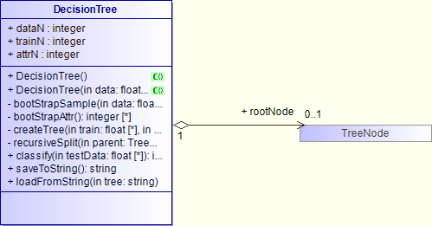

| Name | Description |
| --- | --- |
| DecisionTree () |  |
| DecisionTree (In data float) | constructs a decision tree from a data matrix. |
| bootStrapSample (In data float,Inout train float,Inout test float) | create a boostrap sample of size trainN while leaving others as test data |
| integer bootStrapAttr () | selects attributes of size attrN from sample |
| createTree (In train float,In nTree integer) | creates the decision tree according to the specifications of random forest trees |
| recursiveSplit (In parent TreeNode) | critical function to create the decision tree with the selected attributes of bootstrap sample |
| integer classify (In testData float) | traverses the tree and returns the prediction of the given test data |
| string saveToString () | traverses through tree nodes and returns the string representation of current decision tree |
| loadFromString (In tree string) | recontruct this decision tree object using the string previously generated by toString() |

Table 9 Operations of Class "DecisionTree"

| Name | Description |
| --- | --- |
| dataN : [1..1] integer | total size of the data (training and testing) |
| trainN : [1..1] integer | size of the bootstrap samples to train (assigned by RFLearner) |
| attrN : [1..1] integer | size of the attributes to train (assigned by RFLearner) |

Table 10 Attributes of Class "DecisionTree"

| Name | Description |
| --- | --- |
| ->rootNode : [0..1] TreeNode | root node of this decision tree |

Table 11 Associations of Class "DecisionTree"

## Class "TreeNode"

from Package gforge.RandomForestHOG.DecisionTree

This class contains the elements of a node in tree data structure.

Figure 6 TreeNode (architecture_autodiagram)

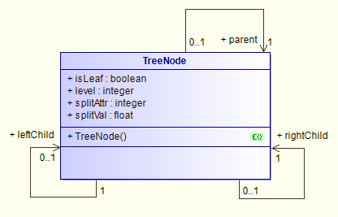

| Name | Description |
| --- | --- |
| TreeNode () | constructs the tree node |

Table 12 Operations of Class "TreeNode"

| Name | Description |
| --- | --- |
| isLeaf : [1..1] boolean | indicates if the node is a leaf |
| level : [1..1] integer | current level in the tree |
| splitAttr : [1..1] integer | attribute to split on |
| splitVal : [1..1] float | value to split splitAttr |

Table 13 Attributes of Class "TreeNode"

| Name | Description |
| --- | --- |
| ->leftChild : [0..1] TreeNode | left child of this node |
| ->rightChild : [1..1] TreeNode | right child of this node |
| ->parent : [1..1] TreeNode | parent of this node |

Table 14 Associations of Class "TreeNode"

# Package "RandomForest"

from Package gforge.RandomForestHOG

| Name | Summary |
| --- | --- |
| RandomForest | Class define the classifier generated by random forest. |
| RandomForestLearner | Class responsible for random forest learning |

Table 15 Owned Classes of Package "RandomForest"

## Class "RandomForest"

from Package gforge.RandomForestHOG.RandomForest

Inherits from: Classifier

This class contains information about the classifier trained with random forest and provides operation to classify images.

Figure 7 RandomForest (architecture_autodiagram)

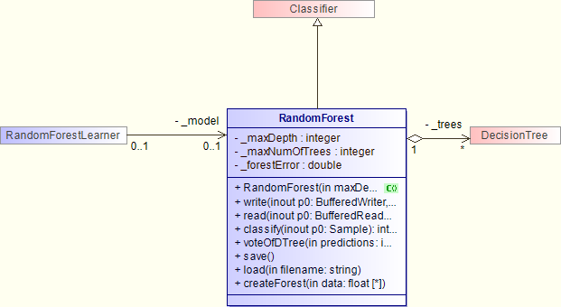

Interaction "RF load"

Figure 8 load

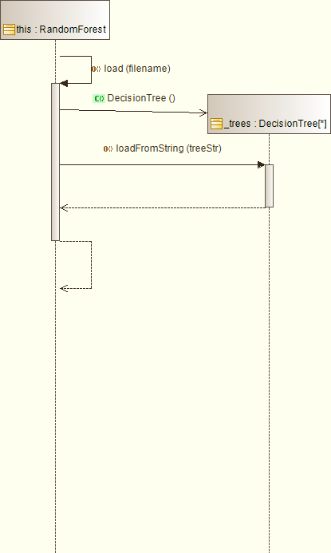

Interaction "RF save"

Figure 9 save

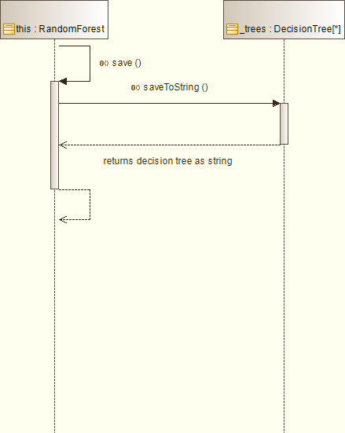

Interaction "RF classify"

Figure 10 Interaction Sequence diagram

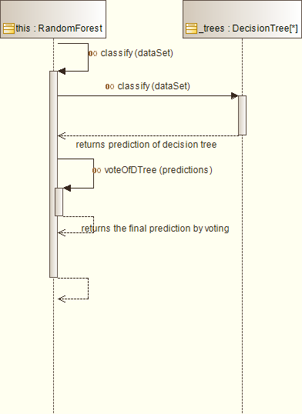

| Name | Description |
| --- | --- |
| RandomForest (In maxDepth Integer,In maxNumOfTrees Integer) | The constructor of random Forest. It takes the following parameters: - the depth of the tree - number of trees in the tree |
| write (Inout p0 BufferedWriter,Inout p1 boolean) | implements write method of Classifier |
| read (Inout p0 BufferedReader) | implements write method of Classifier |
| integer classify (Inout p0 Sample) | returns the classified result of this random forest given data p0 |
| integer voteOfDTree (In predictions integer) | returns the vote (mode) of the predictions of decision trees given test data |
| save () | saves current random forest model |
| load (In filename string) | load previous saved random forest model |
| createForest (In data float) | creates decision trees for the forest |

Table 16 Operations of Class "RandomForest"

| Name | Description |
| --- | --- |
| _maxDepth : [1..1] integer | the depth of the tree. |
| _maxNumOfTrees : [1..1] integer | The maximum number of trees in the forest |
| _forestError : [1..1] double | error of the random forest |

Table 17 Attributes of Class "RandomForest"

| Name | Description |
| --- | --- |
| ->_trees : [0..*] DecisionTree | decision trees of this random forest |

Table 18 Associations of Class "RandomForest"

## Class "RandomForestLearner"

from Package gforge.RandomForestHOG.RandomForest

Inherits from: Learner

This class implements the learning algorithm of random forest inheriting from learner

Figure 11 RandomForestLearner (architecture_autodiagram)

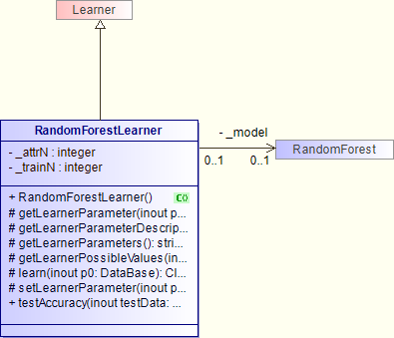

Interaction "RFLearner learn"

Figure 12 learn

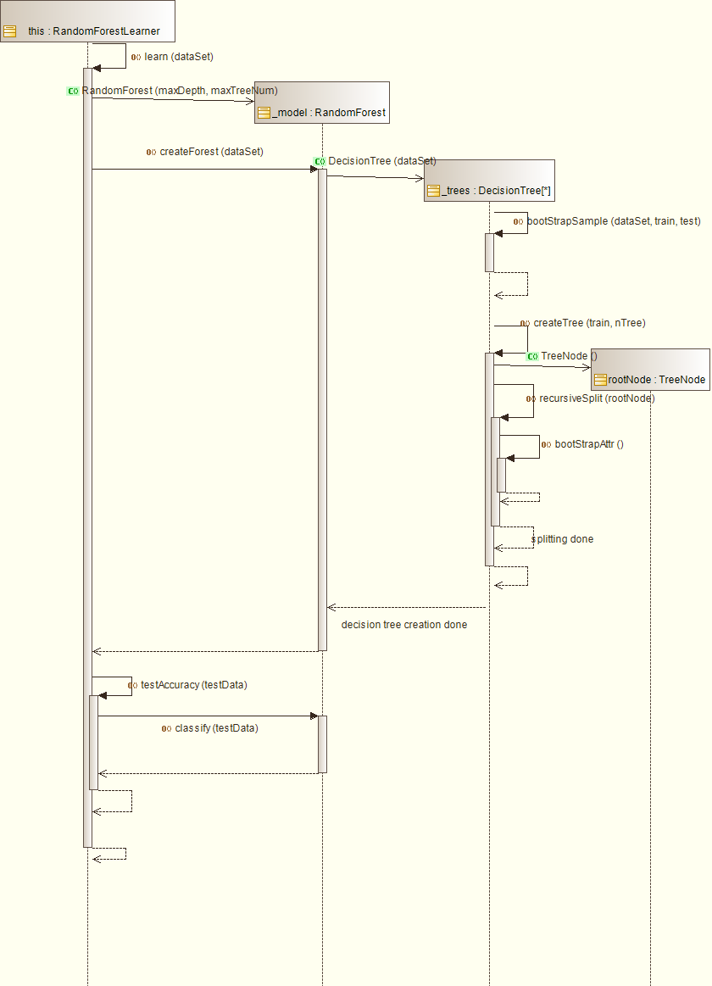

| Name | Description |
| --- | --- |
| RandomForestLearner () | The constructor of RandomForestLearner |
| Object getLearnerParameter (Inout p0 string) | implements getLearnerParameter method of Learner |
| string getLearnerParameterDescription (Inout p0 string) | implements getLearnerParameterDescription method of Learner |
| string getLearnerParameters () | implements getLearnerParameters method of Learner |
| Object getLearnerPossibleValues (Inout p0 string) | implements getLearnerPossibleValues method of Learner |
| Classifier learn (Inout p0 DataBase) | implements learn method of Learner and trains a random forest classifier |
| setLearnerParameter (Inout p0 string,Inout p1 Object) | implements setLearnerParameter method of Learner |
| float testAccuracy (Inout testData DataBase) | tests the accuracy of random forest after forest creation |

Table 19 Operations of Class "RandomForestLearner"

| Name | Description |
| --- | --- |
| _attrN : [1..1] integer | size of attributes to bootstrap |
| _trainN : [1..1] integer | size of data to create bootstrap sample |

Table 20 Attributes of Class "RandomForestLearner"

| Name | Description |
| --- | --- |
| ->_model : [0..1] RandomForest | the random forest classifier model for learner to train |

Table 21 Associations of Class "RandomForestLearner"